PERSONAL PROFILE

Ph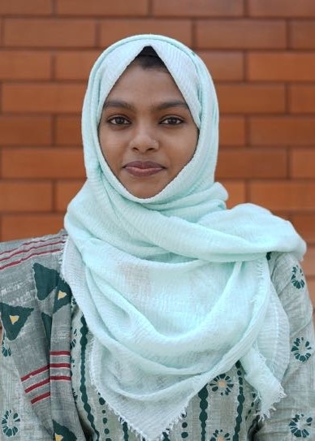oto
(to be taken by Website Photographer)
MUFALLILA TM T M House
Assistant Professor(In contract) Athazhakkunnu
Department of Mathematics (P.O)Kottali,
Sir Syed College Kannur, Kerala, India
Taliparamba Pin Code: 670005

Name : MUFALLILA T M
M.Sc.
Age & Date of Birth : 26& 23-05-1997
Gender : Female
Marital Status : Married
Nationality : Indian
Religion : Islam
Phone No : 9496666567
E-mail : mufallilatm1997@gmail.com
Languages Known : Malayalam,English

Education
Course | Institution | Year | Specialization
M.Sc | Kannur University Campus,  Mangattuparamba | 2019 | Mathematics
B.Sc | KMM Govt. Women’s College, Kannur University | 2017 | Mathematics

Experience
Institution | Designation | From | To
Sir Syed College, Taliparamba | Assistant Professor in contact | 01-08-2023 | Till Date
Sir Syed College, Taliparamba | Assistant Professor in contract | 01-11-2021 | 31-01-2022

I hereby declare that above mentioned information are true to the best of my knowledge and belief.

Taliparamba
2023 MUFALLILA T M

